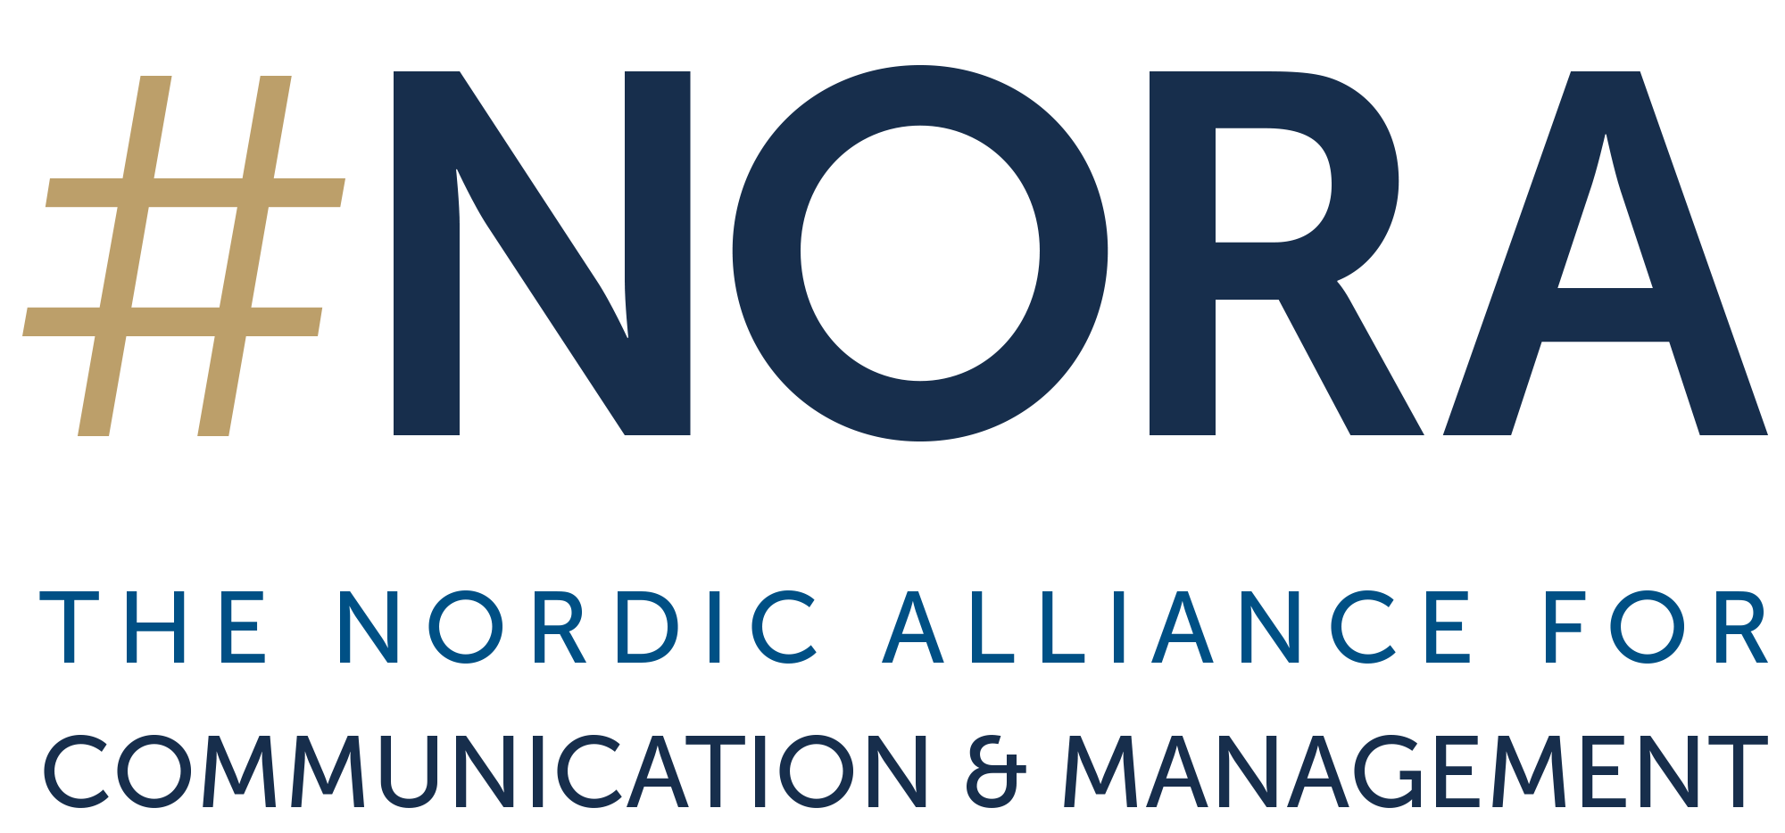
PROGRAM DETAILS
The #NORA Research Fellowship was created to support and publicize the work of early- and mid-career researchers from Nordic institutions who focus on corporate communication, strategic communication and public relations.
#NORA Research Fellows are selected from a competitive pool of international applicants and are offered the opportunity to visit a research institute of their choice from the #NORA network for 1-4 weeks. The Research Fellow will present and discuss their current research at the hosting institution and will provide research transfer (e.g., a webinar and trade article/blog post) that relates their research to current debates among top communication executives in the Nordics and globally.
The selected candidate will get their travel and accommodation reimbursed (to a maximum of NOK 15,000), as well as a NOK 10,000 stipend upon successful completion of the fellowship. In addition, fellows can apply for research assistance as needed and as available during their term.
Up to two fellows will be selected every year.
To apply, please submit the application from with a detailed project description (see instructions below) to nora@bi.no with "ATTN: #NORA Research Fellowship Application" in the subject line by April 20. The results will be announced in early Summer.
Please note that only early- and mid-career researchers from Nordic institutions are eligible for the #NORA Research Fellowship. To be considered an early- or mid-career researcher, the applicant needs to be currently pursuing a PhD or have completed their PhD within the last six years.
About #NORA
#NORA – The Nordic Alliance for Communication & Management is a research-focused and cross-disciplinary think tank that advances evidence-based practice in communication management to drive sustainable organizational performance and success in a changing world. Members strive for advancing evidence-based communication by supporting and developing research, and by facilitating close exchange between researchers and communication executives on best practices and latest insights from research.

Leading communication executives from renowned companies meet regularly with communication and management researchers from Norway, Finland, Sweden, and Denmark. We jointly identify emerging trends and topics, develop new research-based knowledge, and shape the debate in the Nordic countries. Our meetings provide an inspiring and personal atmosphere to exchange ideas between academia and management practice on an equal footing. Virtual workshops and information bulletins help to share insights and experience.
#NORA, as the key think tank in the Nordic region, collaborates with similar initiatives across Europe, and internationally. This helps to apply international debates to the Nordic context and allows to bring our own thinking and approaches into the international discourse.
The participating Universities from the #NORA:
- Aarhus University, Department of Management (Winni Johansen & Finn Frandsen)
- BI Norwegian Business School, Department of Communication and Culture (Alexander Buhmann)
- Copenhagen Business School (Department of Management, Society and Communication)
- Jyväskylä University School of Business and Economics (Vilma Luoma-aho)
- Lund University, Department of Communication and Media (Jesper Falkheimer)
- Mid-Sweden University, Department of Media and Communication Science (Catrin Johansson)

You can learn more about #NORA’s mission and goals on the website.

APPLICATION FORM
#NORA RESEARCH FELLOWSHIP
Please email the application form, a current CV, and a detailed project description per the instructions below to nora@bi.no with "ATTN: #NORA Research Fellowship Application" in the subject line by April 20. The results will be announced in early Summer.
Name:
Title:
Address:
Phone:
Email:
Project title:
[ ] I agree to the terms outlined above

Detailed Project Description/Proposal
Please attach details of your proposed research project. Research proposals should have direct relevance to the current debates among top communication executives in the Nordics and globally. Project descriptions should not exceed 3 pages (double spaced) in length. This must specify purpose, research questions, agenda, and methodological approach.
In a final section please also include a timeline for all deliverables, highlighting the expected submission dates for a transfer article as well as a date and content plan for a webinar (including potential panelists/expert guests) as well as for potential additional outputs. Please also indicate if you envision needing any research assistance (optional).
You can learn more about #NORA’s mission and goals in our strategy.

